A robot is located at the top-left corner of a m x n grid (marked 'Start' in the diagram below).
The robot can only move either down or right at any point in time. The robot is trying to reach the bottom-right corner of the grid (marked 'Finish' in the diagram below).
How many possible unique paths are there?

Example 1:
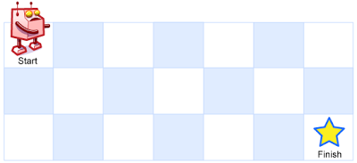
Input: m = 3, n = 7
Output: 28
Example 2:
Input: m = 3, n = 2
Output: 3
Explanation:
From the top-left corner, there are a total of 3 ways to reach the bottom-right corner:
1. Right -> Down -> Down
2. Down -> Down -> Right
3. Down -> Right -> Down
Example 3:
Input: m = 7, n = 3
Output: 28
Example 4:
Input: m = 3, n = 3
Output: 6

Constraints:
- 1 <= m, n <= 100
- It's guaranteed that the answer will be less than or equal to 2 * 10⁹.

